A MINI-PROJECT REPORT ON

***“School Network Design”***

SUBMITTED BY

**PATEL NIMITT CHHOTELAL [19IT5014]**

**JETHWA NIKET KAMLESH [19IT5015]**

**MALI CHIRAG SATYANARAYAN [19IT5016]**

Supervisor

**Mrs. Nilima Dongre**



Department of Information Technology Dr. D. Y. Patil Group’s

Ramrao Adik Institute Of Technology

Dr. D. Y. Patil Vidyanagar, Sector 7, Nerul, Navi Mumbai 400706.

(Affiliated to University of Mumbai)

**2021-2022**



**Ramrao Adik Institute of Technology**

#### (Affiliated to the University of Mumbai)

Dr. D. Y. Patil Vidyanagar,Sector 7, Nerul, Navi Mumbai 400706.

**CERTIFICATE**

This is to certify that, the Mini Project titled

***“School Network Design”***

is a *bonafide* work done by

**PATEL NIMITT CHHOTELAL [19IT5014]**

**JETHWA NIKET KAMLESH [19IT5015]**

**MALI CHIRAG SATYANARAYAN [19IT5016]**

Supervisor

**Mrs. Nilima Dongre**

|  |  |  |
| --- | --- | --- |
| Mini-Project Co-ordinator | Head of Department | Principal |
| **( Mrs. Sumedha Bhagwat )** | **(Dr. Ashish Jadhav)** | **(Dr. Mukesh Patil)** |

**Mini Project Approval**

This is to certify that the Mini Project entitled School Network Design is a bonafide work done by

*Patel Nimitt Chhotelal, Jethwa Niket Kamlesh, Mali Chirag Satyanarayan* under the guidance of *Mrs.Nilima Dongre*. This work has been approved as a Mini Project for Third year Information Technology.

Examiners :

1. . . . . . . . . . . . . . . . . . . . . . . . . . . . . . .

2. . . . . . . . . . . . . . . . . . . . . . . . . . . . . . .

Supervisors :

1. . . . . . . . . . . . . . . . . . . . . . . . . . . . . . .

2. . . . . . . . . . . . . . . . . . . . . . . . . . . . . . .

Date : Place :

# Declaration

I declare that this written submission represents my ideas in my own words and where other’s ideas or words have been included, I have adequately cited and referenced the original sources. I also declare that I have adhered to all principles of academic honesty and integrity and have not misrepresented or fabricated or falsified any idea/data/fact/source in my submission. I understand that any violation of the above will be cause for disciplinary action by the Institute and can also evoke penal action from the sources which have thus not been properly cited or from whom proper permission has not been taken when needed.

|  |  |
| --- | --- |
| Nimitt Chhotelal Patel-19IT5014 |  |
| Niket Kamlesh Jethwa- 19IT5015 |  |
| Chirag Satyanarayan Mali-19IT5016 |  |

Date:

# Abstract

The main aim of the project is to design a suitable network system for the school. We are focusing on considering a network design for an area with one head office and three sub branches. This project will provide a backup of data and security to the network with minimum cost and proper bandwidth utilization. There are many devices that were used in designing the network, such as routers, switches, firewall, and servers. All of these utilities have been configured to provide a secure environment for the entire network and to prevent external attacks from accessing sensitive information. Improving the performance of any network requires a high quality of techniques and services which help to improve the general task of the network.

# Contents

Declaration I

Abstract II

Table Of Figures IV

Introduction 1

Objectives 2

Network Requirements 3

Major Design Areas and Functional Areas 4

Infrastructure 6

Networking Devices 7

Request For Proposal 9

Remote Site Connectivity 10

IP Address Planning 11

Routing Protocol Plan 13

Network Design (Actual Topology) 15

Conclusion 17

References 18

# Table Of Figures

Figure 1: VLAN Configuration 4

Figure 2: The above design is the existing network traced on cisco packet tracer 6

Figure 3: Above is the pictorial representation of the proposed network 8

Figure 4: Routing Protocol Plan for Router0 13

Figure 5: Routing Protocol Plan for Router1 14

Figure 6: Routing Protocol Plan for Router2 14

Figure 7: The prototype of the proposed network is implemented on cisco packet tracer 15

Figure 8: Testing VLAN communications from HOD Cabin to Internet Lab 15

Figure 9: Testing Web Hosting 16

Figure 10: Testing FTP Server 16

# Introduction

This School Network Scenario is about designing a topology of a network that is a LAN (Local Area Network) for a School in which various computers of different departments are set up so that they can interact and communicate with each other by interchanging data. To design a networking scenario for a school which connect various departments to each other’s, it puts forward communication among different departments. CNS is used to design a systematic and well-planned topology, satisfying all the necessities of the school (i.e. client). CNS come up with a network with good performance.

Various networking features are applied over the network. The FTP and the DNS servers are maintained, the access is also restricted to the authorized user making the networking as per the school requirements. The Head of Departments are able to communicate over the network with other authorities of various department be it primary or secondary. The systems made available for students have several restrictions and have limited access over the network. Fewer websites are also being restricted over the network using the ACL approach, limiting the unwanted access over the Internet.

# Objectives

The main objective of the proposed network is to update the existing network and also enhance its capabilities and increase the flexibility of the network which will eventually provide good security.

Keeping the network simple, uncluttered yet functional enough for its users. Establish a secure network overall the departments, and ensuring its complete availability for its users whenever required.

To ensure easy and quick maintenance of the servers and network devices over the network.

To provide accessible networking system throughout the school enterprise and making it flexible and scalable without any hassle.

# Network Requirements

1. The new system should be able to reduce internet downtime. Download and upload links should be maintained above 5 Mbps speed requirement.
2. Network will be scalable.
3. The system should support remote access.
4. Should comprise of data centres with necessary security features and support.
5. The required connecting devices should be made available while establishing the networking.
6. The networking devices should have the provision to be easily replaced and scale to further level.

# Major Design Areas and Functional Areas

The new system planned comprises of IP based switches that remain as the access point to lan-based (ethernet) as well as Wi-Fi-based connectivity.

These switches provide SNMP support as well so that traffic monitoring becomes easy.

Ip based switches are used mainly because:

• The inter VLAN routing feature is supported on both IP base or SMI and IP services or EMI image Layer 3 switches. For Layer 2-only switches, you require a Layer 3 routing device with any of the previous images.



Figure 1: VLAN Configuration

• The IP Base feature set includes advanced quality of service (QoS), rate limiting, access control lists (ACLs), and basic static and Routing Information Protocol (RIP) functions. Dynamic IP routing protocols (Open Shortest Path First (OSPF), BGPv4, Enhanced Interior Gateway Routing Protocol (EIGRP)) are available only on the IP services image.

• The IP Services image provides a richer set of enterprise-class features, which includes advanced hardware-based IP unicast and IP Multicast routing. Support for IPv6 Layer 3 switching in hardware is also available with the addition of the Advanced IP Services license to either the IP Base or the IP Services images. Both the IP base Image and the IP services image allow for Layer 3 and Layer 4 lookups for QoS and security.

# Infrastructure

The existing system is a very basic system. School mainly comprises of three main sections as

1. Departments

2. Exam Centre

3. Office

All the hosts are assigned with static IPs and are assigned in the order in which it was set up. No support for dynamic IP allocations. Even though the working is divided into three major sectors all the host, multimedia devices are connected in a single network. Thus, network security and maintenance are difficult. One more problem observed was the existing switches were outdated and hence could not prove to be beneficial for the network administrator to observe monitor and handle the network traffic the system has no remote access to the network. Absence of basic small-scale businesses firewall was also observed. Thus, security is also compromised. Three server rooms were used for the purpose of independent networking which further caused wastage of power and money.



Figure 2: The above design is the existing network traced on cisco packet tracer

# Networking Devices

Developing the existing Lan system:

• The basis of the LAN core is Cisco Catalyst 6509 switches equipped with Cisco 720 supervisors and Virtual Switching System (VSS), as well as Cisco 4500 switches, combined in a stack with the data transmission ports at 10 Gb/s bandwidth capacity. Switches create a platform for additional services, such as content processing, firewall (the project uses the Cisco firewall), intrusion prevention system, application of IPsec security tools, the arrangement of protected VPN channels, network analysis and acceleration of Secure Sockets Layer (SSL) connections.

Mobility Services Engine (MSE) solution and 300 Cisco Aironet 1140 access points were used.

• The Cisco Aironet 1140 Series is a component of the Cisco Unified Wireless Network, which can scale up to 18,000 access points with full Layer 3 mobility across central or remote locations on the enterprise campus, in branch offices, and at remote sites.

• The Cisco Unified Wireless Network is the industry’s most flexible, resilient, and scalable architecture, delivering secure access to mobility services and applications and offering the lowest total cost of ownership and investment protection by integrating seamlessly with the existing wired network.



Figure 3: Above is the pictorial representation of the proposed network

Cisco Unified Computing System (UCS) solution allowed the integration of computer and network resources as well as storage and virtualization systems as part of an energy efficiency system. Cisco Unified Computing System platform notably simplifies traditional architecture and significantly reduces the number of devices to be purchased, to connect by wires, to supply with electricity and cooling, to protect and maintain. This solution is the foundation of complex optimization of the virtualized medium while maintaining the ability to support traditional operating systems and applications stacks in physical medium. This overall infrastructure developed allowed integration of several functionally different physical networks into one, such as guest network, hotel management network, telephone network and IP-Television network. The convergence within single network reduced hotel expenses for constructing and managing several dedicated networks which traditionally remain separate in hotels.

The term unified computing system is often associated with Cisco. Cisco UCS products have the ability to support traditional operating system (OS) and application stacks in physical environments, but are optimized for virtualized environments. Everything is managed through Cisco UCS Manager, a software application that allows administrators to provision the server, storage and network resources all at once from a single pane of glass. Similar offerings to Cisco UCS include HP BladeSystem Matrix, Liquid Computing's LiquidIQ, Sun Modular Datacenter and InteliCloud 360.

# Request For Proposal

The request for proposal which will satisfy the complete design of the network is mentioned below:



# Remote Site Connectivity

**Use a reliable virtual private network (VPN):** By providing a VPN service to all staff and students where necessary, their online activities are the same as if they were sitting at school, the secured network. All traffic is encrypted and protected by the school’s local network security measures. It’s important to recognize that not all VPN services are created the same. Some only encrypt the data in transfer, but not application data. Others collect data to sell to third parties.

**Avoid sharing resources for work/learning and personal use**. For students with school devices, it is best practice not to share your device across users. Additionally, it's not a good idea to access or download non-school applications from these devices. Doing this increases the chances of malware, or other malicious code entering the school's network

**Install cyber security tools such as firewall and AV on home networks:** Communicate with parents to educate them on installing or updating their cyber security measures on the home network. This includes firewalls as a first line defence to prevent threats entering and a good antivirus software that can act as the next line of defence by detecting and blocking known malware.It’s also important to update and patch all apps and browsers and ensure they are on auto update to prevent cyber criminals exploiting known security vulnerabilities.

# IP Address Planning

Primary Department (192.168.1.0)

|  |  |
| --- | --- |
| HOD CABIN | 192.168.1.2 |
| PC 1 | 192.168.1.3 |
| PC 2 | 192.168.1.4 |
| PC 3 | 192.168.1.5 |
| PC 4 | 192.168.1.6 |
| Printer 0 | 192.168.1.7 |

Secondary Department **(**192.168.2.0**)**

|  |  |
| --- | --- |
| HOD CABIN | 192.168.2.2 |
| PC 1 | 192.168.2.3 |
| PC 2 | 192.168.2.4 |
| PC 3 | 192.168.2.5 |
| PC 4 | 192.168.2.6 |
| Printer 1 | 192.168.2.7 |

Server Room **(**1.0.0.0**)**

|  |  |
| --- | --- |
| FTP SERVER | 1.0.0.4 |
| PC1 | 1.0.0.5 |
| DNS SERVER | 1.0.0.6 |
| WEB SERVER | 1.0.0.7 |

Principal Room (192.168.4.0)

|  |  |
| --- | --- |
| **PC 0** | 192.168.4.2 |
| Laptop 0 | 192.168.4.3 |

Library (128.168.0.0)

|  |  |
| --- | --- |
| **PC2** | **128.168.0.2** |
| PC3 | 128.168.0.3 |
| PC4 | 128.168.0.4 |
| PC5 | 128.168.0.5 |
| PRINTER 5 | 128.168.0.6 |

# Routing Protocol Plan

Routing Information Protocol (RIP) is a dynamic routing protocol which uses hop count as a routing metric to find the best path between the source and the destination network. It is a distance vector routing protocol which has AD value 120 and works on the application layer of OSI model.

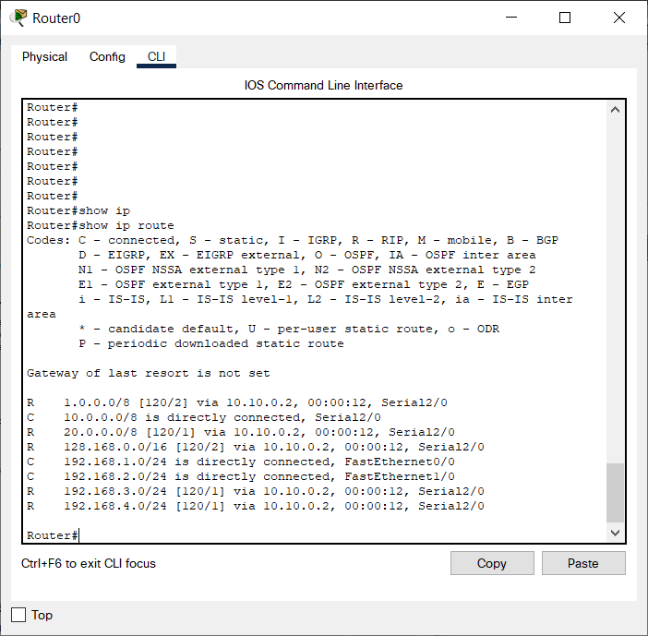

Figure 4: Routing Protocol Plan for Router0

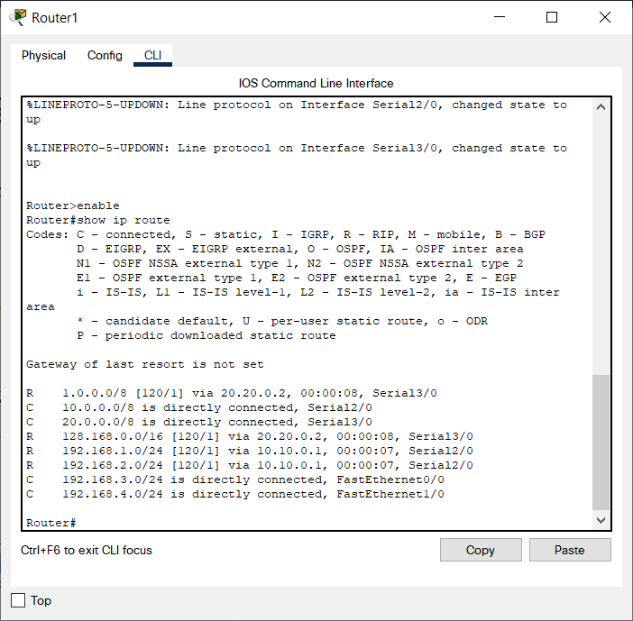

Figure 5: Routing Protocol Plan for Router1

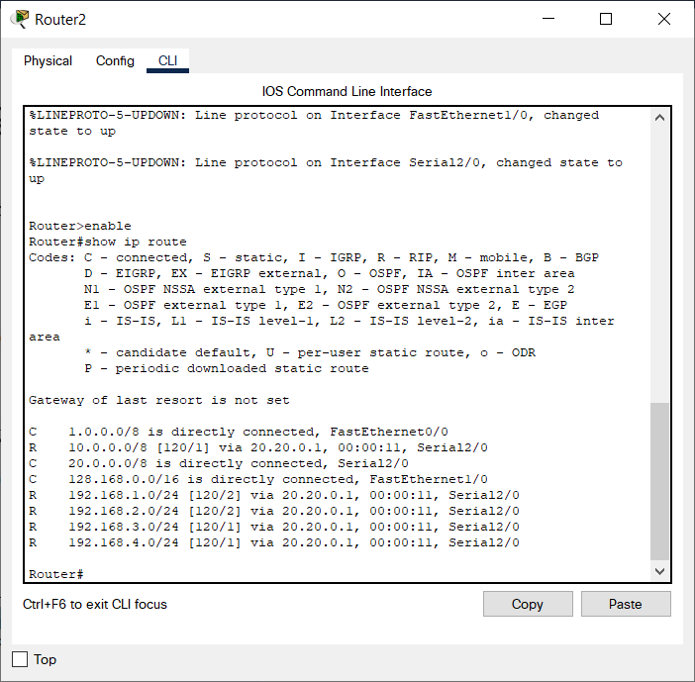

Figure 6: Routing Protocol Plan for Router2

# Network Design (Actual Topology)

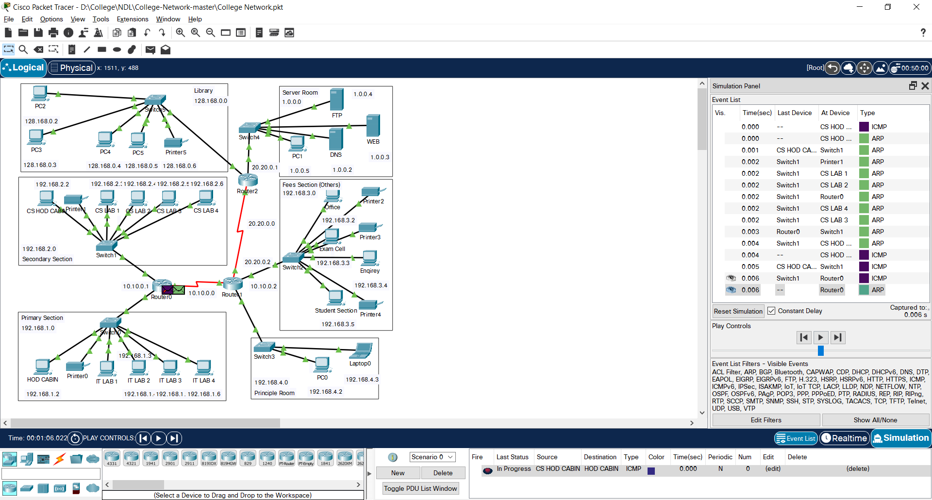

Figure 7: The prototype of the proposed network is implemented on cisco packet tracer

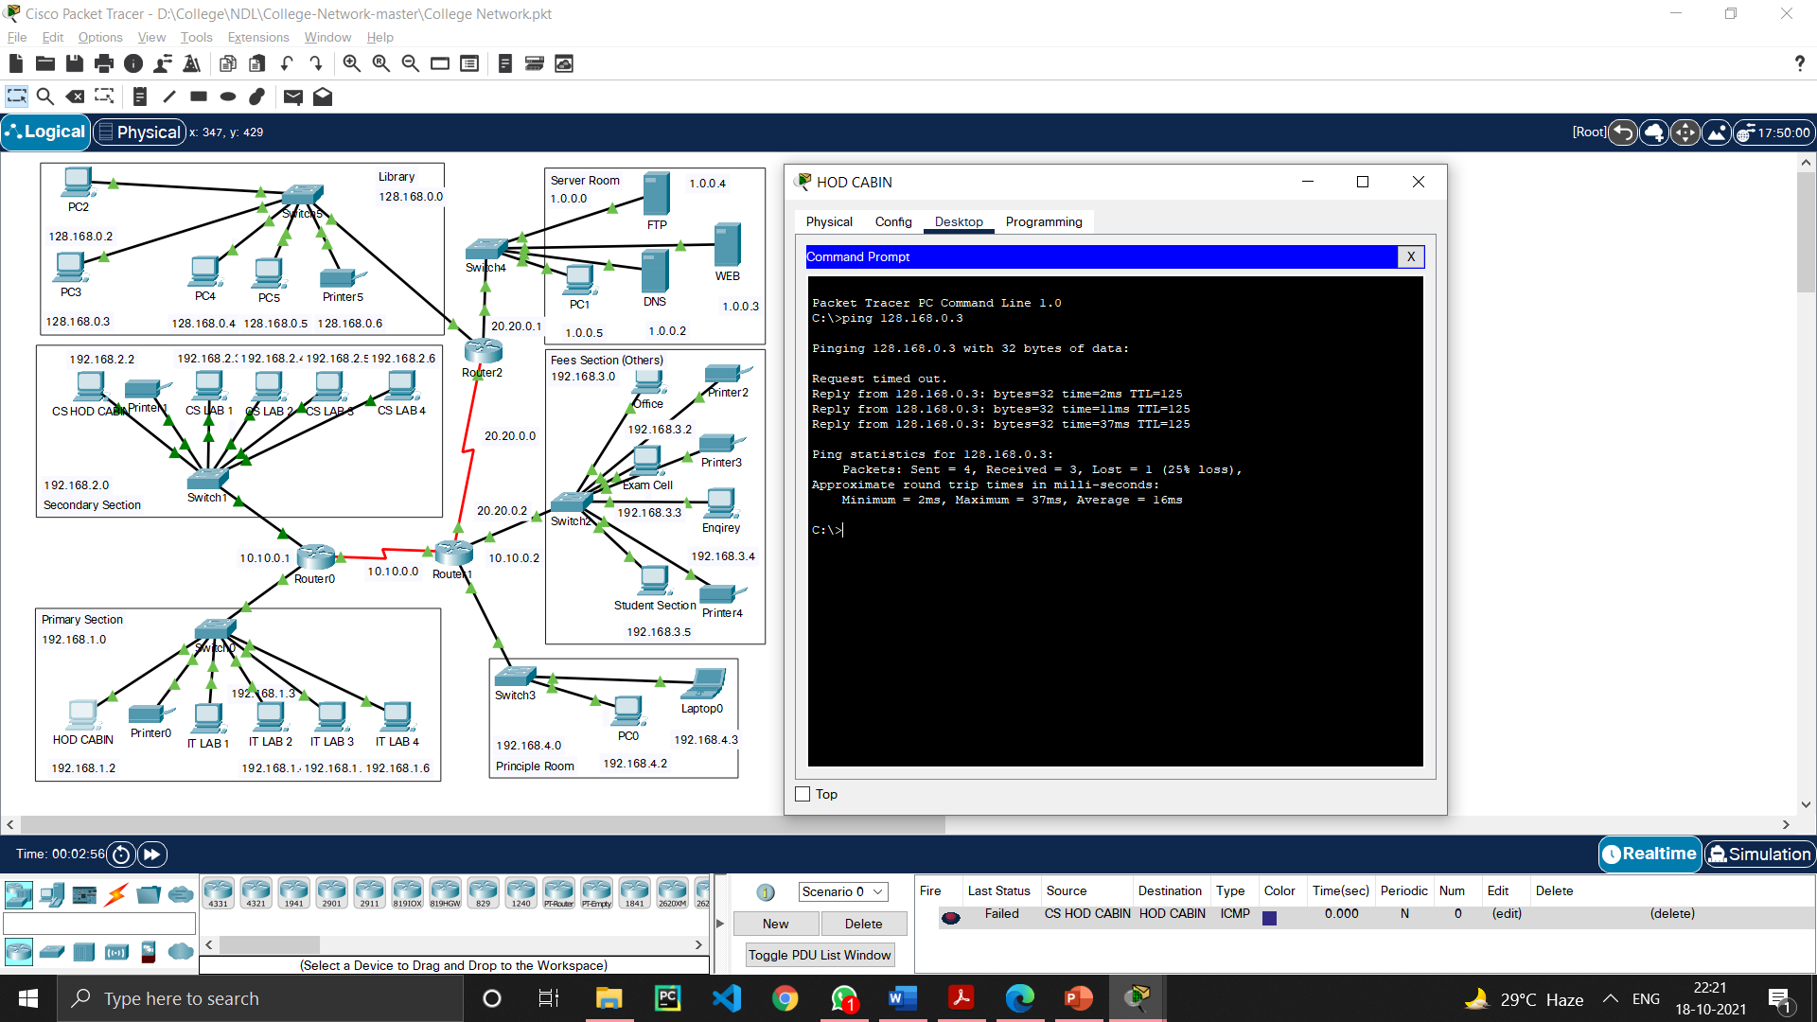

Figure 8: Testing VLAN communications from HOD Cabin to Internet Lab

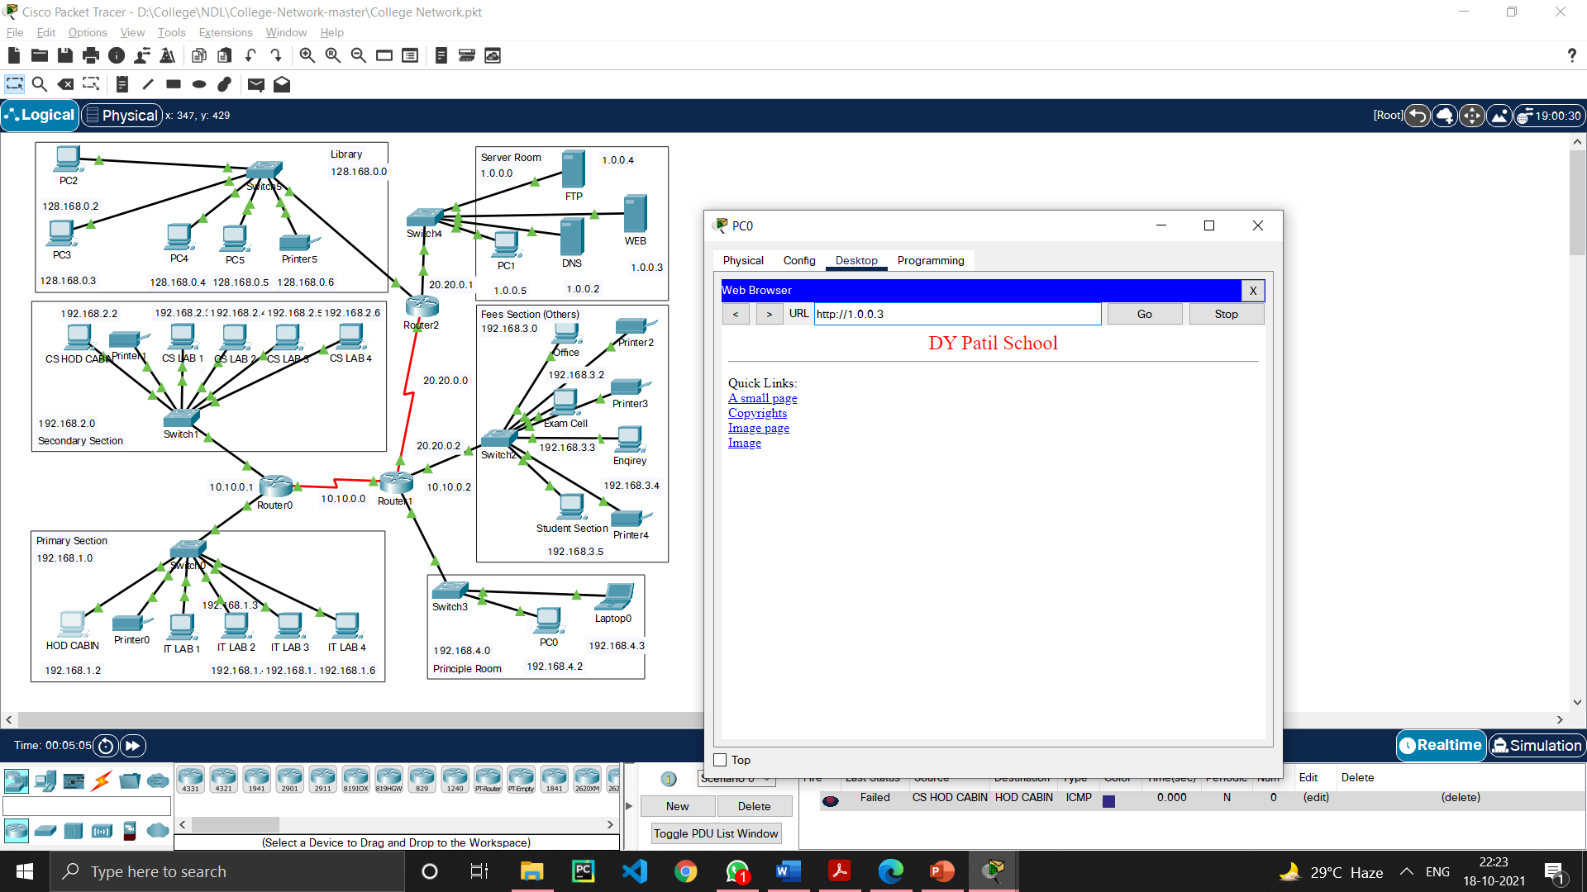

Figure 9: Testing Web Hosting

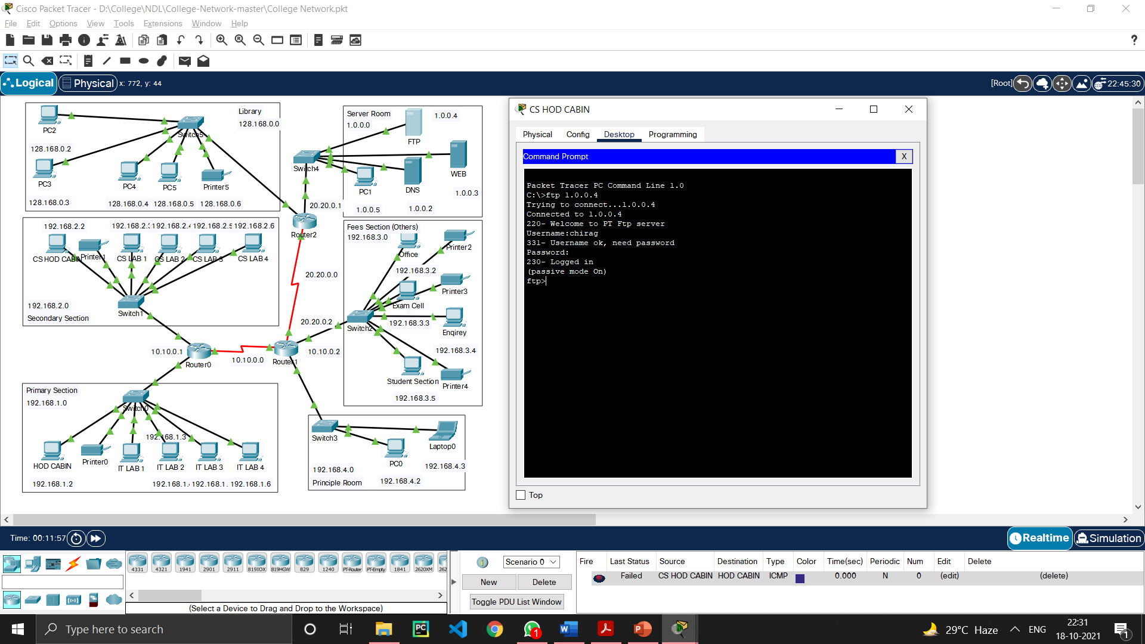

Figure 10: Testing FTP Server

# Conclusion

The outcome of the proposed system will be a fail-safe backbone network infrastructure which meets the requirements for readily available access to information and security of the private network, and also ensures optimized productivity when telecommunication services are accessed. The installed equipment allowed to organize high-speed wired and wireless Internet access throughout the whole complex of hospital buildings as well as providing transfer of all types of data throughout the single optimized network.

# References

1. Sun, L., Wu, J., Zhang, Y., & Yin, H. (2013, April). “Comparison between physical devices and simulator software for Cisco network technology teaching”. In Computer Science &Education (ICCSE), 2013 8th International Conference on (pp. 1357-1360). IEEE
2. Roberto Minerva AbiyBiru, "Towards a Definition of the Internet of Things” IEEE IOT Initiative white paper.
3. “Design and Simulation of Local Area Network Using Cisco Packet Tracer”. The International Journal of Engineering and Science (IJES) || Volume || 6 || Issue || 10 || Pages || PP 63- 77 || 2017 || ISSN (e): 2319 – 1813 ISSN (p): 2319 – 1805.
4. Qin, X. U. E. "Simulation Experimental Teaching of Computer Network Based on Packet Tracer [J]." Research and Exploration in Laboratory 2 (2010): 57-59.
5. Current, John R., Charles S. ReVelle, and Jared L. Cohon. "The hierarchical network design problem." European Journal of Operational Research 27.1 (1986): 57-66.

**Presentation**

